|  |
| --- |
| **Dr. Savvides Ambrosios-Antonios** |

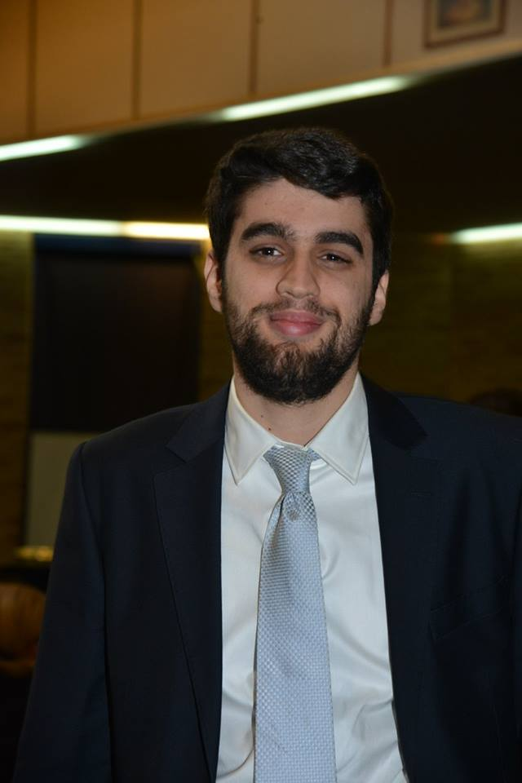

Nationality: Greek/Cypriot Gender: Male Single Born: 12/5/1990

Sirou 8 Iraklio Attica 14122 - Athens  
Mobile 00306942584124   
Email: [ambrosavvides@hotmail.com](mailto:ambrosavvides@hotmail.com)

|  |
| --- |
| **Education** |

* 2002-2008 Secondary Education in the Hellenic American Educational Foundation Athens College (HAEF). Graduated with grade 19 “Honorary graduation”
* 2008-2013 Bachelor of Civil Engineer at National Technical University of Athens (NTUA). Graduated with grade 8,78 (8th best in the year 2013 amongst 268 total graduates)
* 2013-2014 Master of Science in Civil Engineering «Analysis and Design of Earthquake Resistant Structures» NTUA. Graduated with grade 8,86
* 2014-2021 PhD candidate at NTUA- Institute of Structural Analysis and Antiseismic Research (ISAAR)
* 2021 PhD graduation and Dr Nominated with Dissertation «Uncertainty quantification in Geotechnical Engineering». https://www.didaktorika.gr/eadd/handle/10442/50006

|  |
| --- |
| **Expierence** |

* 2015-2021 Free Market-Entrepreneurship- Participation in refurbishments and retrofit of structures.
* 2010-2013 NTUA Instructor of courses “Mathematics for Engineering” in undergraduate students.
* 2013-2021 Teaching Assistant of Professor NTUA Manolis Papadrakakis in the following undergraduate courses in School of Civil Engineering NTUA:
* Statics 4-Dynamics of Structures, Statics 5-Plastic analysis of beam elements, Finite Element Analysis, Matlab, Programming (Languages Python C#), Statics 3-Statics with Matrices-Finite Element Method for Beam Elements
* 2016-Practical Internship in Athens International Airport (ΑΙΑ)-PRAXIS.
* 2019-2020 Teacher in the School of Engineering of the Hellenic Army for Lessons
* Concrete-Building Materials-Architecture-Construction techniques
* 2018-2019 Teacher in the School of Technical Education for Under Officers in the Hellenic Air Force for Lessons
* Concrete-Retrofit of structures-Prefabricated structures
* 2021-2022 Teacher in the School of Technical Education for Officers in the Hellenic Army for Lessons
* Bridge Construction-Finite Elements-Soil Mechanics-Foundations-Diplomas
* 2021-2022 Lecturer in the Department of Civil Engineering in University of Thessaly in Lessons
* Dynamics of structures 1-2-Finite Elements,
* 2022-Today Lecturer in the following universities
* Hellenic Naval Academy- Applied Mechanics Hellenic Air Force Academy-Architecture-Buildings- Statics of Structures National Technical University of Athens-Surface bearing loading bodies-Special issues in Finite Element Method University of West Attica Engineering Mechanics and Reinforced Concrete
* 2021- Postdoctoral researcher in Institute of Structural Analysis and Antiseismic Research in Research programs with aim the programming of Material Constitutive Modelling with particular emphasis in materials of soils and composite materials. Member of the Research Group MGROUP (<http://mgroup.ntua.gr/>) and participation in the programming in the respective scientific areas of the Open Source Numerical Finite Element Code MSolve (<https://github.com/mgroupntua>)
* 2023 Authoring the Theory Manual of the code MSolve as a part of a Scientific Responsible Group of the code.

|  |
| --- |
| **Academic rewards-Merits** |

* 2005 2nd’ Award in the Hellenic Mathematical Society contest “Euclid” and 3rd’ Award in the Hellenic Mathematical Society contest “Archimid”
* 2006 1st’ Award in the Hellenic Mathematical Society contest “Euclid”
* 2007 3rd’ Award in the Hellenic Mathematical Society contest “Euclid” and 2nd’ Award in the Hellenic Mathematical Society contest “Archimid”
* 2008 Secondary Education in the Hellenic American Educational Foundation Athens College (HAEF). Graduated with grade 19 “Honorary graduation”
* 2008 Secondary Education in the Hellenic American Educational Foundation Athens College (HAEF). Graduated with the “Mathematics Award” given to the best student in Mathematics.
* 2013-2017 Scholarship of Bodossaki Foundation for Doctoral Studies
* 2013-2021 Participation and organization in the conferences of European Committee on Computational Mechanics (ECCOMAS) which are presented in a separate paper.
* 2020- Scientific publications which are presented in a separate paper

|  |
| --- |
| **Languages** |

* Greek (Mother Language)
* English (LTE C1 Language Knowledge)
* French (DELF A2-B2 Language Knowledge)

|  |
| --- |
| **Programming Languages** |

* Programs Matlab Mathematica Nastran-Femap SCIA
* Programming Languages Matlab Java Fortran C#
* Operating Systems Ms Windows – Word – Excel

|  |
| --- |
| **Endorsements** |

* Understanding the static behavior of load bearing bodies and qualitative approach to the loads and stresses in seismic and static loads (engineer judgement) and knowledge of the mechanical properties and constitutive modelling of Materials and Geomaterials

|  |
| --- |
| **Targets-Interests** |

* Deepening in the concepts of Stochastic-Probabilistic Analysis in all the problems of Engineering through improving the code of the applications of the ISAAR in order to increase their ability and performance
* In the Academia to be a member of a distinguished University and reach the title of Full Professor

|  |
| --- |
| **Miscelleaneous Interests** |

* Scientific History, Ancient Literature, Football (Amateur participation in the sport) Karate, Athletics

|  |
| --- |
| **Miscelleaneous** |

* Amateur Driving License 2010.
* Military service in the Hellenic Airforce from 07/2020-04/2021 in the School of Under Officers in the Public Relations Office